COURSE CERTIFICATE

This is to certify that

Francis Emmanuelle L. Pontinela

has successfully completed the course by demonstrating

theoretical and practical understanding of

Introduction to C#



Certificate CC-N6ZDTN5S

Issued 05 December, 2023

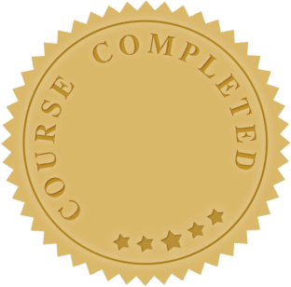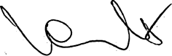

**Yeva Hyusyan**

Chief Executive Officer